Payeer for CMS UMI 15

Open the FTP client server, and transfer the contents of the module folder in the root directory of your site with the replacement of files and folders.
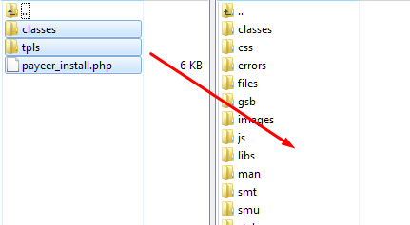

After copying, run the setup module Payeer, writing in the address bar
***/payeer_install.php
where *** is the domain name of your website (for example, payeer.com/payeer_install.php)
After successful installation of module, delete the file payeer_install.php from the root of the site.
Go to admin panel, go to “Configuration” in the modules, and click the “Caching” tab.
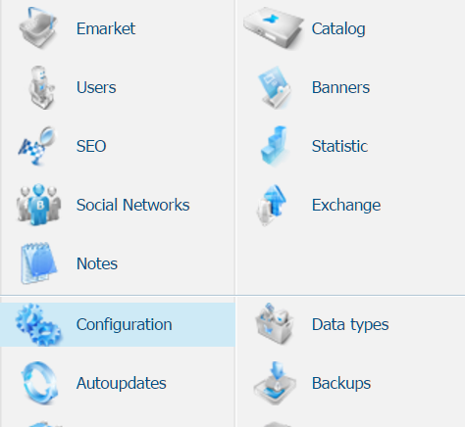

Click “Flush cache”
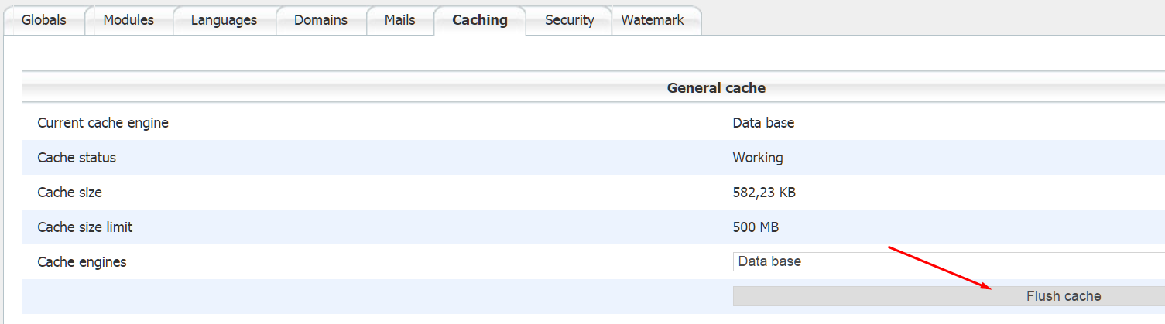

In the modules, open the "Emarket"
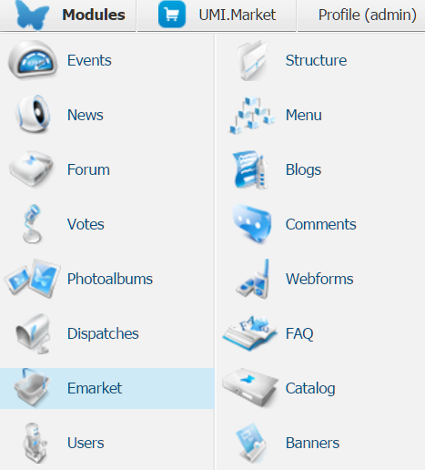

Go to the tab "Payments", point to "Add payment method" and select "Payeer"
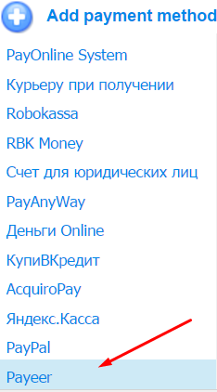

Specify the name of the payment system and payment method Payeer.
Fill in all required fields in the settings of the payment module Payeer
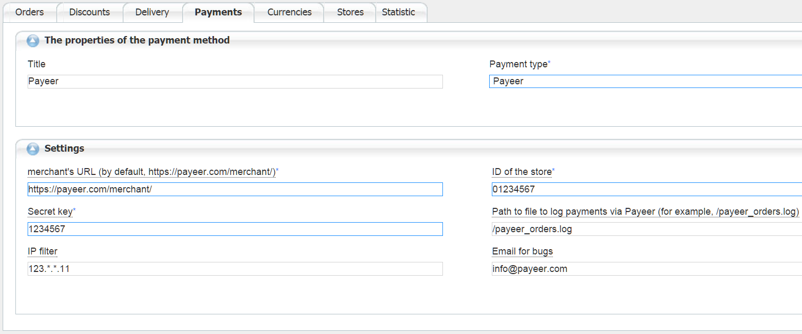
Specify the properties and settings:
URL of the merchant — the default path to the payment https://payeer.com/merchant/
ID of the store - ID of your store in the system Payeer.com (can be found in the personal cabinet).
Secret key – the secret key of your store.
You can specify the list of all trusted ip addresses of servers, separated by commas. You can also specify a mask instead of the IP address. If the field is empty, checking for trusted IP addresses is not implemented.
For example:
192.168.71.87, 192.165.83.17, 192.178.34.15
or 192.*.71.87, 192.165.83.*, 192.*.34.15
or *.*.*.* - all available IP addresses.

Enter your email address to receive notices in the event of an error of payment. The letter will state the reason and basic information about the payment.
If you specify the path to the file logging, you will be recording information about payments via Payeer.
Click "Add and exit"
Configuring the module in admin panel completed.

Enter the URL address in the “account Payeer → Merchant → Settings”

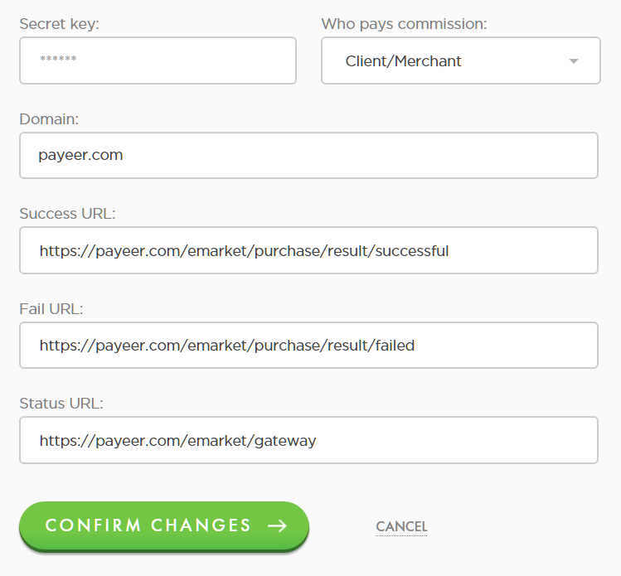

Success URL
http:// *****/emarket/purchase/result/successful
Fail URL
http:// *****/emarket/purchase/result/failed
Status URL
http:// *****/emarket/gateway
Where ***** is your domain
Confirm changes.
Payeer module for CMS UMI 15 configured.

